SIMATS ENGINEERING
ASSESSMENT TOOL 1

COURSE NAME: MLA03
COURSE CODE: Reinforcement learning for Environment and Agent

COURSE OUTCOME COVERED

CO2: Apply Dynamic Programming methods to solve reinforcement learning problems and derive optimal policies for decision-making tasks. (BL2, BL3)

Assessment Tool Weightage: 35%
Dr G. A. SENTHIL

QUESTIONS: 10 Total Marks: 50

Annexure A

Industry Problem Task Duration: 2.5hrs

1. Explain how Reinforcement Learning can be applied to optimize delivery routes in a logistics system. Identify the possible states, actions, rewards, and policy. Discuss how continuous learning improves efficiency over time. (5 Marks)

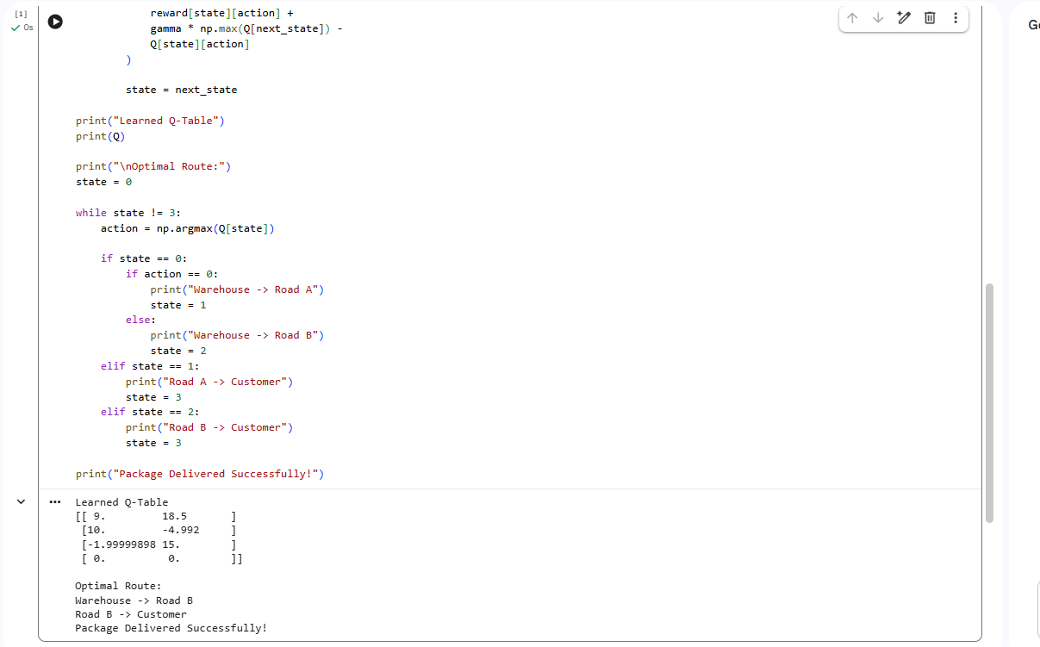
2. Apply Reinforcement Learning concepts to a fraud detection system in fintech. Define the state space, action space, and reward mechanism. Explain how exploration strategies improve detection accuracy. (5 Marks)
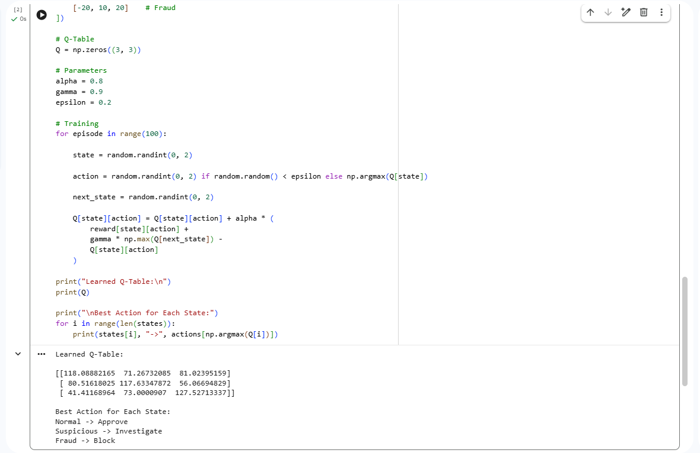
3. Illustrate how Reinforcement Learning is used in a streaming platform for content recommendation. Discuss the impact of delayed rewards, user feedback, and changing preferences on learning performance. (5 Marks)
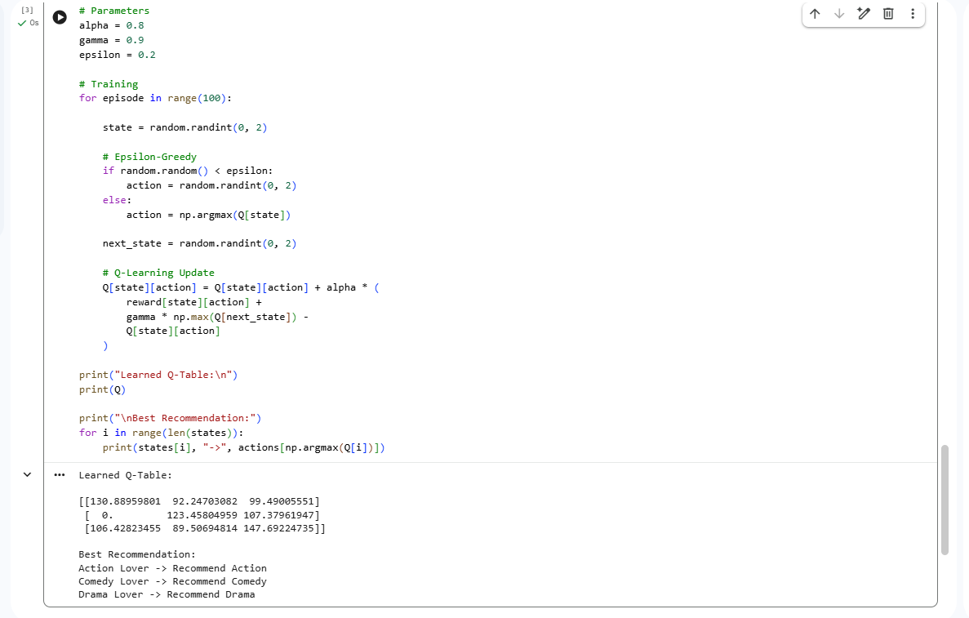

4. Evaluate the effectiveness of Reinforcement Learning in predictive maintenance compared to traditional rule-based approaches. Discuss risks and reliability concerns in industrial environments. (5 Marks)

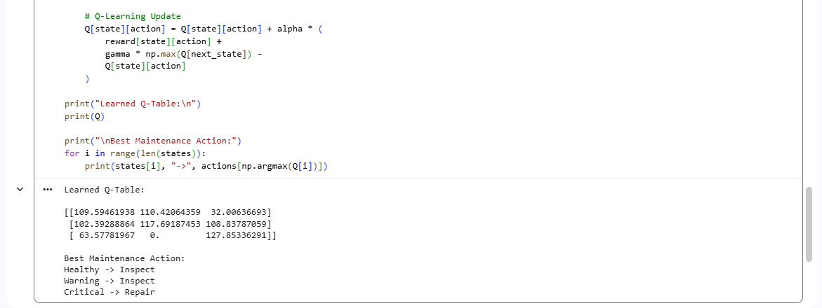

5. Analyze how Reinforcement Learning can be used to optimize transportation systems such as bus scheduling or route allocation. Define states, actions, and rewards, and discuss how real-time data improves performance. (5 Marks)

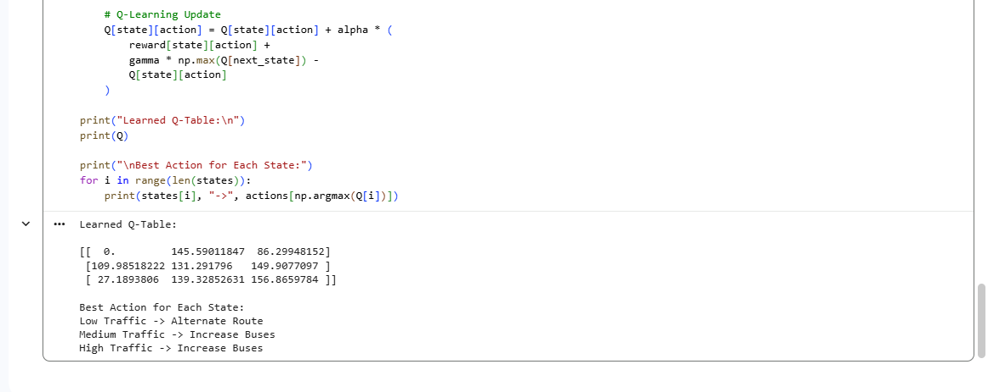

6. Apply Reinforcement Learning to dynamic pricing in e-commerce. Define the state space, action space, and reward function. Discuss challenges in balancing exploration and exploitation. (5 Marks)

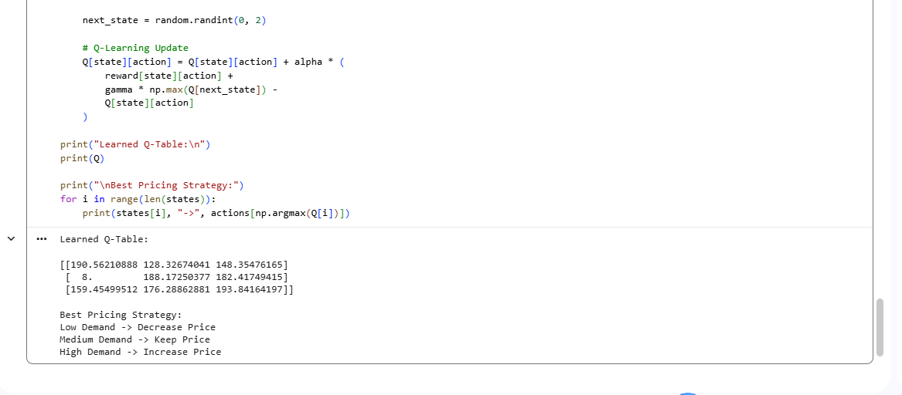

7. Illustrate the use of Reinforcement Learning in smart city waste management systems. Identify the MDP components and discuss how continuous updates improve operational efficiency. (5 Marks)

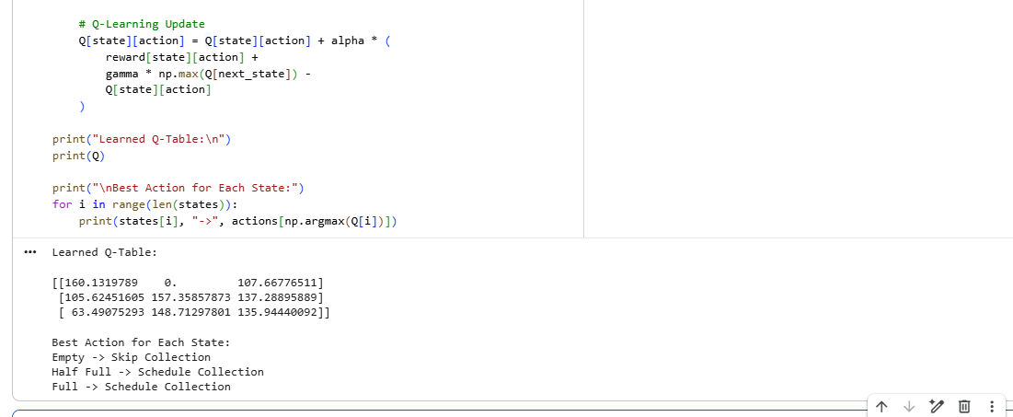

8. Evaluate how Reinforcement Learning can be used in network bandwidth allocation in telecommunications. Define states, actions, and rewards, and examine how the system adapts to dynamic conditions. (5 Marks)

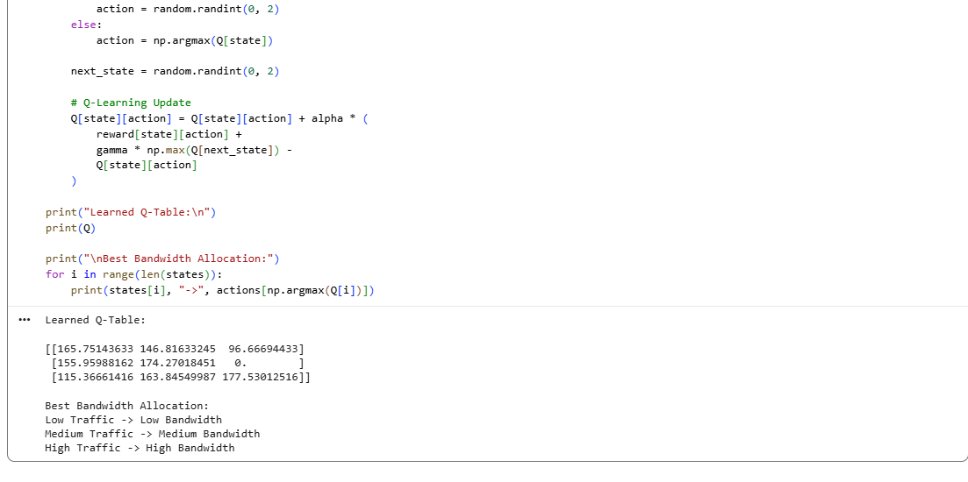

9. Analyze the application of Reinforcement Learning in portfolio management in finance. Discuss advantages over traditional models and challenges such as risk and delayed rewards. (5 Marks)

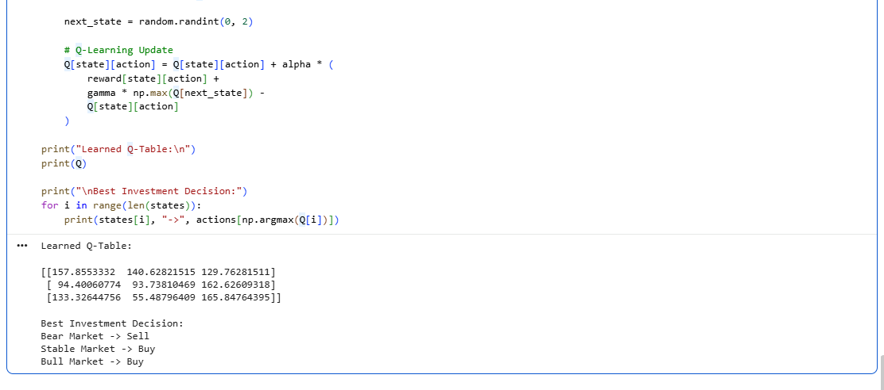

10. Justify the use of Reinforcement Learning in renewable energy management systems. Define the RL framework components and discuss the impact of environmental uncertainty on decision-making. (5 Marks)
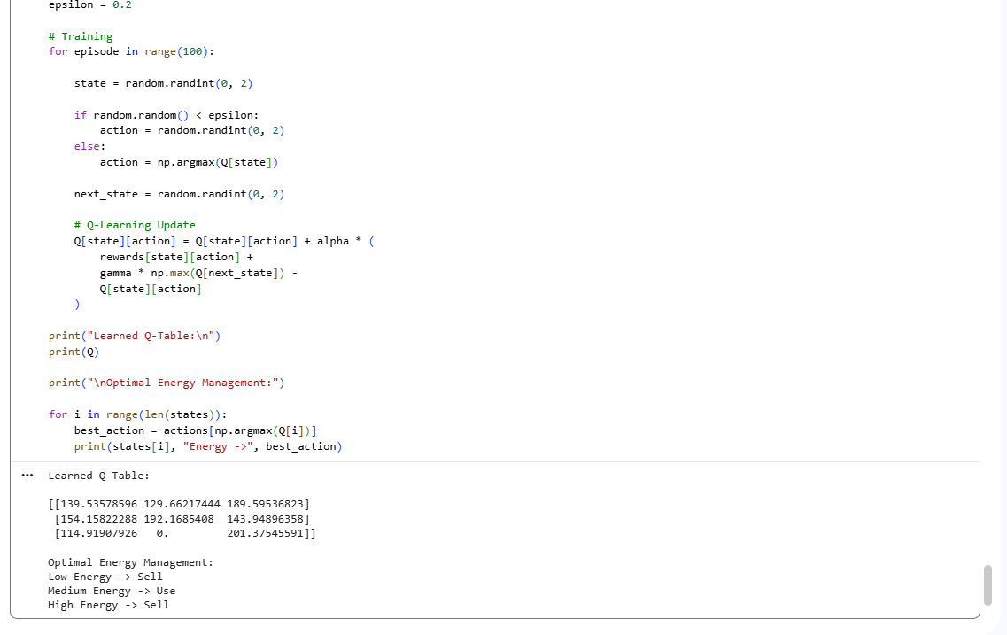

Code of Conduct:

I _M.Samanvi(192425318)___ (Name / Reg No) certify that this submission is my original work and that I have adhered to the guidelines specified for this assessment.
I understand that any violation of academic integrity rules will result in disciplinary action.

Signature of the student: M.Samanvi

RUBRICS FOR CALCULATION

Criteria | Weightage | Level 4 – Exemplary | Level 3 – Proficient | Level 2 – Developing | Level 1 – Beginning
Criteria | Weightage | Level 4 – Exemplary | Level 3 – Proficient | Level 2 – Developing | Level 1 – Beginning
Understanding of Industry Problem | 20% | Comprehensive understanding of real-world problem and constraints | Good understanding with minor gaps in requirements | Basic understanding; some requirements unclear | Poor understanding; misinterprets problem context
Application of Engineering Concepts | 25% | Applies advanced and relevant concepts effectively to solve the problem | Applies appropriate concepts with minor errors | Limited application of concepts | Incorrect or no application of concepts
Solution Design | 25% | Innovative, practical, and feasible solution aligned with industry standards | Logical and feasible solution with minor gaps | Basic solution with limited feasibility | Unclear or impractical solution
Use of Tools | 15% | Effective use of modern tools, technologies, and real data | Appropriate use of tools with correct implementation | Limited or inconsistent use of tools | Minimal or incorrect use of tools
Analysis | 10% | Thorough analysis with validated results and performance evaluation | Good analysis with reasonable validation | Basic analysis with limited validation | Poor or no analysis
Professionalism | 5% | Highly professional, well-documented, and clearly presented work | Good documentation and presentation | Basic documentation with some gaps | Poor documentation and presentation

